REQUIREMENT GATHERING AND ANALYSIS
Functional requirements
A. User Authentication & Authorization management
- The system shall allow users to log in using a username (Registration Number and staffID) and password
- The system shall support role-based access (Coordinator, Supervisor, Project Student, Research Student, Normal Student)
- The system shall prevent unauthorized access to restricted features
- Account creation for students (temporary password via university email)
- Password reset functionality
- Verify student Registration Number against SIS
- Confirm Enrollment Status = Active
- Determine student role based on year of study:
  - Eligible years → Project/Research Student
  - Other years → Normal Student
- Import required student records from SIS into local system (read-only)
B. Project & Research Management
Coordinator Requirements
- The system shall allow the coordinator to create student accounts
- The system shall allow the coordinator to create project groups (2 or more students)
- The system shall allow the coordinator to register individual research students
- The system shall allow the coordinator to assign supervisors to groups or students
- The system shall allow the coordinator to view all groups and students
- The system shall allow the coordinator to track progress of all projects and research
- The system shall allow the coordinator to view approved groups ready for presentation
- The system shall allow the coordinator to access archived projects and research
- The system shall allow the coordinator to sees only students who are active, in eligible year for project/research, in the same department or programme
Supervisor Requirements
- The system shall allow supervisors to view assigned groups and students
- The system shall display student details (name, registration number, phone, email)
- The system shall allow supervisors to view submitted proposals, reports, demos, and source code
- The system shall allow supervisors to add comments and feedback
- The system shall allow supervisors to approve or reject project stages
- The system shall allow supervisors to digitally approve final presentation forms
- The system shall allow supervisors to track progress for each assigned project
Student Requirements
- The system shall allow students to log in using registration credentials
- The system shall allow students to view assigned supervisor details
- The system shall allow students to upload proposals, reports, demos, and source code
- The system shall allow students to download submitted and approved files
- The system shall allow students to view supervisor comments and feedback
- The system shall allow students to track project status until final approval
- The system shall allow students to view and download previous projects (read-only)
Project & research requirements
- The system shall support multiple project stages (proposal, development, demo, final)
- The system shall store all documents and source code securely
- The system shall archive completed projects for future reference
D. Notifications
- Notify students of:
  - Temporary password on first registration via email and phone number
  - Supervisor comments
  - Approval status changes
  - Notify supervisors of new submissions via email
E. File Management
- Upload and download functionality for project/research documents
- Maintain version history of submissions
- Support multiple file types (PDF, DOCX, ZIP for source code)
F. Reporting & Tracking management
- Track project/research progress by group or individual
- View previous project/research reports
- Generate summary reports for coordinators and supervisors
Table 1 FR-01: Student Account Registration
Field | Description
Requirement No. | FR-01
Actor(s) | Student, System
Pre-Conditions | Student exists in SIS; Enrollment status = Active
Input | Registration Number
Normal Flow | 1. Student enters registration number.  2. System validates number against SIS.  3. System retrieves student details.  4. System creates account and assigns role.  5. Temporary password is generated.
Output | Student account created
Post-Conditions | Account exists with correct role; temporary password sent

Table 2 FR-02: First Login & Password Change
Field | Description
Requirement No. | FR-02
Actor(s) | Student
Pre-Conditions | Account created, temporary password issued
Input | - Registration Number  - Temporary Password  - New Password
Normal Flow | 1. Student logs in with temporary password.  2. System forces password change.  3. Student sets a new password.  4. System validates and saves password.
Output | Password updated
Post-Conditions | Account activated with permanent password

Table 3 FR-03: Role Assignment Based on Eligibility
Field | Description
Requirement No. | FR-03
Actor(s) | System
Pre-Conditions | Student record retrieved from SIS
Input | - Year of Study  - Program
Normal Flow | 1. System checks year of study.  2. System matches eligibility rules.  3. System assigns Project/Research or Normal Student role.
Output | Role assigned
Post-Conditions | Student has corrected system access level

Table 4 FR-04: View Eligible Students
Field | Description
Requirement No. | FR-04
Actor(s) | Coordinator
Pre-Conditions | Coordinator logged in
Input | - Department  - Programme  - Year of Study filters
Normal Flow | 1. Coordinator selects filters.  2. System retrieves active and eligible students.  3. System displays filtered list.
Output | Eligible students list
Post-Conditions | Coordinator can proceed with grouping/assignment

Table 5 FR-05: Create Project Groups
Field | Description
Requirement No. | FR-05
Actor(s) | Coordinator
Pre-Conditions | Eligible students available
Input | - Selected student list  - Group name
Normal Flow | 1. Coordinator selects students.  2. Coordinator creates group.  3. System validates group size.  4. System saves group.
Output | Project group created
Post-Conditions | Students linked to a project group

Table 6 FR-06: Assign Supervisor
Field | Description
Requirement No. | FR-06
Actor(s) | Coordinator
Pre-Conditions | Supervisor and students/groups must exist
Input | - Supervisor ID  - Student/Group ID
Normal Flow | 1. Coordinator selects supervisor.  2. Coordinator selects group/student.  3. System records assignment.  4. System sends notification.
Output | Supervisor assigned
Post-Conditions | Supervisor linked to project/research

Table 7 FR-07: Upload Project Documents
Field | Description
Requirement No. | FR-07
Actor(s) | Project/Research Student
Pre-Conditions | Student logged in, and eligible role
Input | Document file (PDF/DOCX/ZIP), Stage
Normal Flow | 1. Student selects project stage.  2. Student uploads file.  3. System validates file type and size.  4. System stores file and version.
Output | Submission recorded
Post-Conditions | Document available for supervisor review

Table 8 FR-08: Review Submissions
Field | Description
Requirement No. | FR-08
Actor(s) | Supervisor
Pre-Conditions | Supervisor assigned to project
Input | Selected submission
Normal Flow | 1. Supervisor opens submission.  2. System displays uploaded files.  3. Supervisor reviews content.
Output | Submission opened
Post-Conditions | Submission ready for feedback

Table 9 FR-09: Provide Feedback
Field | Description
Requirement No. | FR-09
Actor(s) | Supervisor
Pre-Conditions | Submission reviewed
Input | - Comments  - Recommendations
Normal Flow | 1. Supervisor enters feedback.  2. System saves comments.  3. System notifies student.
Output | Feedback stored
Post-Conditions | Student can view supervisor feedback

Table 10 FR-10: Approve or Reject Project Stage
Field | Description
Requirement No. | FR-10
Actor(s) | Supervisor
Pre-Conditions | Feedback provided
Input | Approval decision (Approve/Reject)
Normal Flow | 1. Supervisor selects decision.  2. System updates project status.  3. System sends notification.
Output | Updated project status
Post-Conditions | Project moves to next stage or requires revision

Table 11 FR-11: View Archived Projects
Field | Description
Requirement No. | FR-11
Actor(s) | Student, Coordinator
Pre-Conditions | User authenticated
Input | - Search  - filter criteria
Normal Flow | 1. User searches archived projects.  2. System retrieves approved projects.  3. System displays read-only files.
Output | Archived project list
Post-Conditions | No modification to archived data

Table 12 FR-12: Send Notifications
Field | Description
Requirement No. | FR-12
Actor(s) | System
Pre-Conditions | Trigger event occurs
Input | Event type (submission, feedback, approval)
Normal Flow | 1. System detects trigger.  2. System prepares message.  3. System sends email/SMS.
Output | Notification delivered
Post-Conditions | Recipient informed of system event

Table 13 FR-13: Synchronize SIS Data
Field | Description
Requirement No. | FR-13
Actor(s) | System
Pre-Conditions | Secure SIS connection available
Input | SIS student records
Normal Flow | 1. System connects to SIS.  2. System retrieves required fields.  3. System updates local database.
Output | Updated student records
Post-Conditions | Local data matches SIS (read-only)

Non functional requirements
- Accessibility
- Interoperability
- Maintainability
- Accuracy
- Response time
- Security
- Timelines
- Auditability
- Extensibility
- Robustness
REGISTRATION PROCESS
The registration process defines how different users are enrolled into the system while enforcing access boundaries.
- student record pooling from sis (data synchronization)
Step 1: identify required student records
Retrieve only the following fields from sis, registration number, full name, programme, department, year of study, university email, phone number, enrollment status (active / suspended/graduated).
Step 2: data retrieval method
Secure API connection to sis or periodic import of verified student records
Step 3: data storage in proposed system
Store retrieved records locally in the system database, and Mark all fields as read-only
Step 4: periodic synchronization
Enrollment status updated periodically to reflect sis changes, and graduated or inactive students are automatically disabled
- student registration process (first-time access)
Step 1: registration number submission
Student enters their registration number into the system
Step 2: sis verification
System checks if registration number exists in sis, and enrollment status is equal to active, if verification fails should display the notification that registration denied and if verification succeeds should proceed
Step 3: conditional role assignment
Determine eligibility based on year of study and programme the system checks if the year is eligible for project or research and assign project or research student role if not assign normal student role
Step 4: account creation
System creates user account using reg no, assigns the determined role, and sets account status to active
Step 5: password generation
System generates random temporary password, password is hashed before storage, and temporary password sent to student’s email and phone number
Step 6: first login
Student logs in with reg no and temporary password, and System forces a password change
- normal login process
- Student enters registration number and password
- System verifies password hash
- System checks enrollment status (from local database or sis sync)
  - System applies role-based access for Project or research student with full project or research functionality, and Normal student with read-only access to previous projects
- Access granted based on role
- coordinator login verification
Coordinator logs in using system credentials, and System authenticates coordinator
FLOW CHART
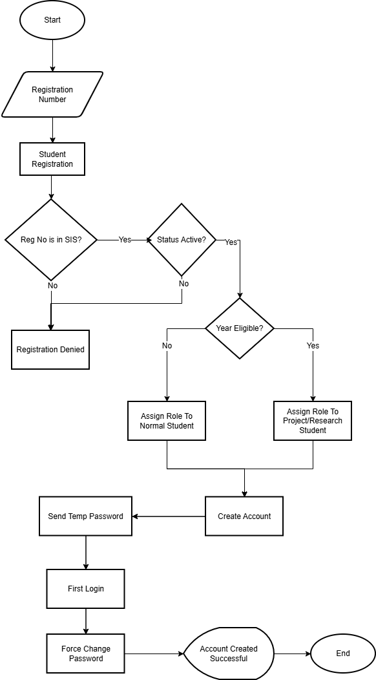
Figure 1 PRMS registration process
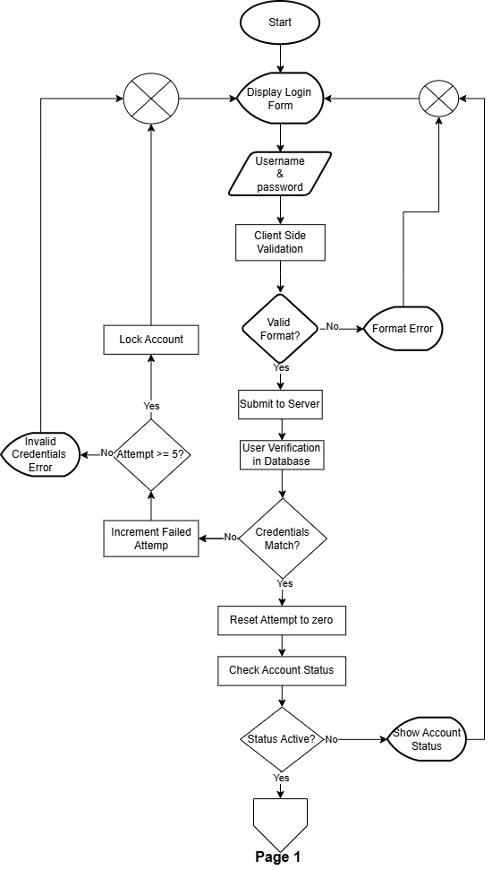
Figure 2 PRMS login process 01
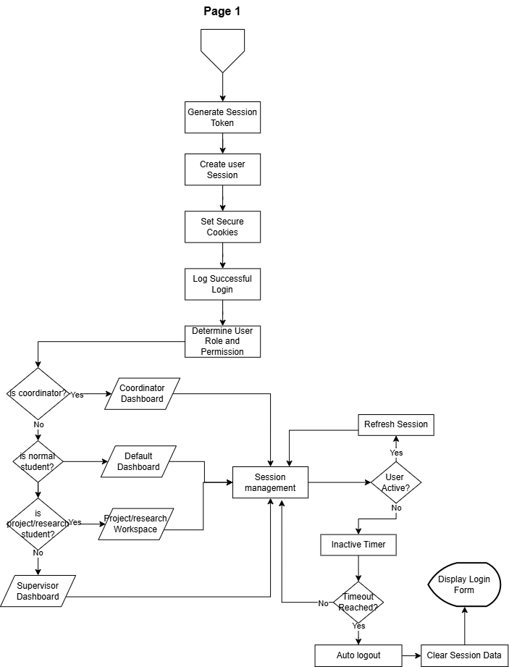
Figure 3 PRMS login process 02
Project, and research management system - user actors, and tasks
1. Student
- Authentication & registration
Submit registration number for first-time access
Log in with temporary password on first login
Change temporary password (forced on first login)
Log in with registration number and password (normal login)
Reset password if forgotten
- Project/research activities (project/research students only)
View assigned supervisor details
Upload project artifacts, proposals, reports, demos, and source code
Download submitted and approved files
View supervisor comments and feedback
Track project status through stages
- General activities (all students)
View previous projects/research (read-only)
Download previous projects (read-only)
- Notifications
Receive temporary password via email/phone
Receive notifications for supervisor comments
Receive notifications for approval status changes

2. Coordinator
- Authentication
Log in using system credentials
- User management
Create student accounts manually (if needed)
View all active students (filtered by department and program)
See only eligible students (active, in project/research year)
- Project/research management
Create project groups (2+ students)
Register individual research students
Assign supervisors to groups/individuals
View all groups and students
Track progress of all projects/research
View approved groups ready for presentation
Access archived projects/research
3. Supervisor
- Authentication
Log in using system credentials
- Project/research management
View assigned work
View assigned project groups
View assigned individual research students
View student details, name, registration number, phone number, email
- Review & evaluation
View submitted materials, proposals, reports, demos, source code, add comments and feedback, approve or reject project stages, digitally approve final presentation forms
- Tracking
Track progress for each assigned project
- Notifications
Receive email notifications for new submissions
4. SIS (external system)
- Data provision
Serve as authoritative student data source
Provide student records via api/file export
Provide enrollment status updates

Actor – role – activity – action
Table 14 Student actor, role, activity and actions
Role | Activity | Actions
Normal Student | Authentication | Register, Login, Change Password, Reset Password
 | Project Review | View and download archived projects (read-only)
Project/Research Student | Supervisor Access | View assigned supervisor details
 | Project Submission | Upload proposals, reports, demos, source code
 | Feedback Review | View supervisor comments
 | Progress Tracking | Monitor project stages
All Students | Notifications | Receive password, feedback, and status alerts

Table 15 Coordinator actor, role, activity and actions
Role | Activity | Actions
Coordinator | Authentication | Login using system credentials
 | Student Management | View and filter active students
 | Eligibility Control | View eligible project/research students
 | Project Management | Create groups and register research students
 | Supervisor Assignment | Assign supervisors to students/groups
 | Monitoring | Track progress and view approved projects
 | Archiving | Access archived projects

Table 16 Supervisor actor, role, activity and actions
Role | Activity | Actions
Supervisor | Authentication | Login using system credentials
 | Assignment Viewing | View assigned groups and students
 | Submission Review | View proposals, reports, demos, source code
 | Feedback | Add comments and recommendations
 | Approval | Approve or reject project stages
 | Progress Tracking | Monitor assigned project milestones
 | Notifications | Receive alerts for new submissions

Table 17 SIS actor, role, activity and actions
Role | Activity | Actions
SIS | Data Provision | Provide verified student records
 | Status Updates | Provide enrollment status changes

System Use Case Diagram
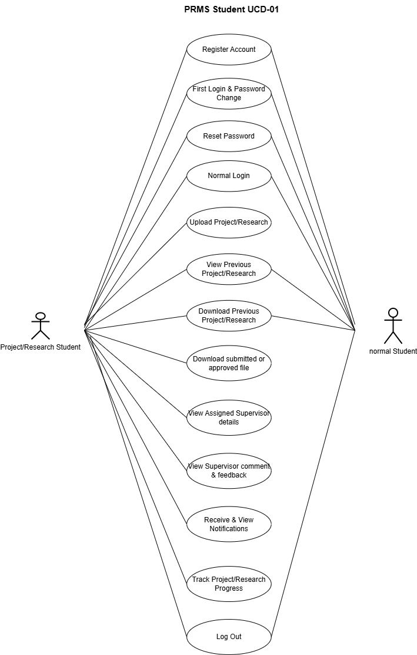
Figure 4 PRMS student Use Case Diagram 01
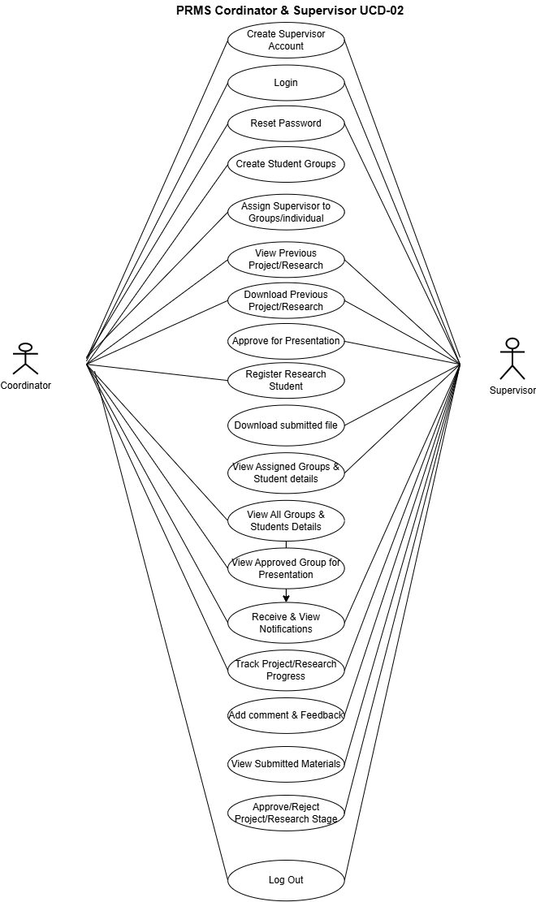
Figure 5 PRMS coordinator and supervisor Use Case Diagram 02

